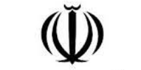

Islamic Republic IRAN

Ministry of Science, Research & Technology
International Relation & Cooperation Center

ANNONCEMBNT
INTERNATIONAL CONFERENCE
Title of Conference:
Date:
Place (Country & City):
Host Organization:
Website:
Tel:
Fax:
Email:

